Eclipse Web專案整合JPA 3.0.4 + JDK17
- 首先建立 Maven Web Project(mvwebjpa)
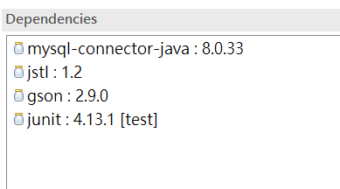
<dependency>
<groupId>mysql</groupId>
<artifactId>mysql-connector-java</artifactId>
<version>8.0.33</version>
</dependency>
<dependency>
<groupId>javax.servlet</groupId>
<artifactId>jstl</artifactId>
<version>1.2</version>
</dependency>
<dependency>
<groupId>com.google.code.gson</groupId>
<artifactId>gson</artifactId>
<version>2.9.0</version>
</dependency>
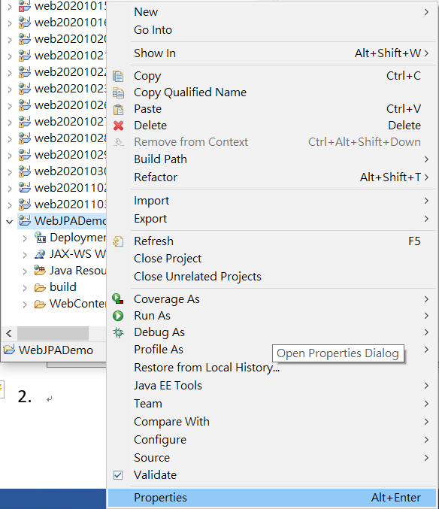
- 選擇 Project / Properties
- 選擇 Project Facets / 選擇 Further configuration available
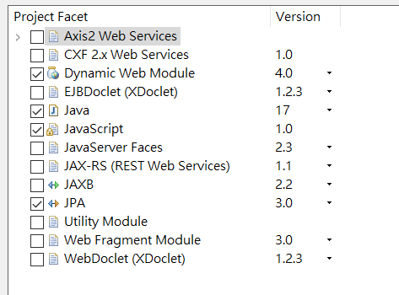
- 選擇 Connection / add driver library to build path
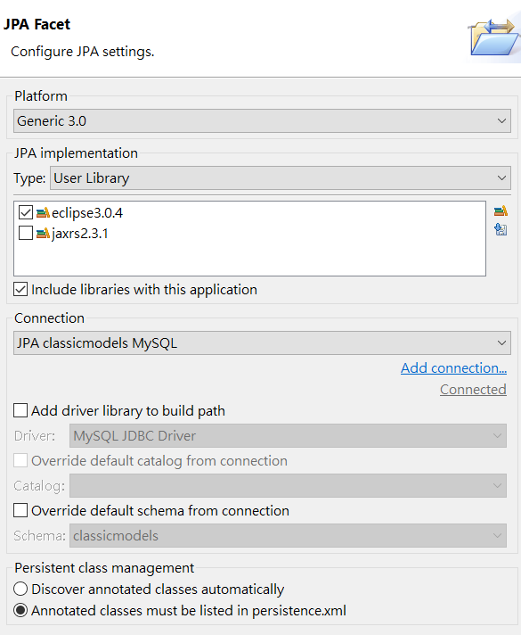
- 修改persistence.xml / Connection
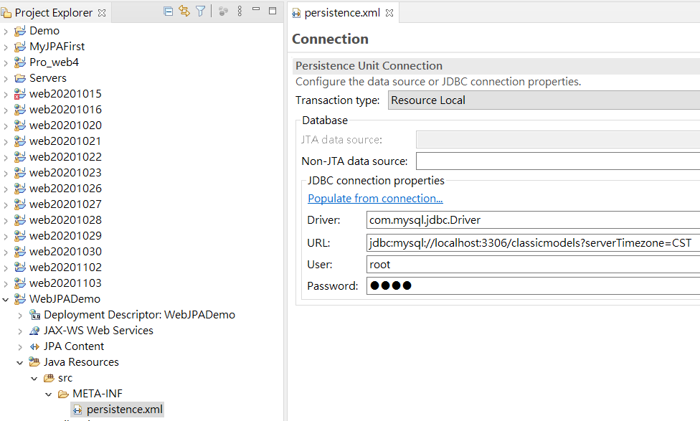
<?xml version="1.0" encoding="UTF-8"?>
<persistence version="3.0" xmlns="https://jakarta.ee/xml/ns/persistence" xmlns:xsi="http://www.w3.org/2001/XMLSchema-instance" xsi:schemaLocation="https://jakarta.ee/xml/ns/persistence https://jakarta.ee/xml/ns/persistence/persistence_3_0.xsd">
<persistence-unit name="mvjpa0325" transaction-type="RESOURCE_LOCAL">
<properties>
<property name="jakarta.persistence.jdbc.url" value="jdbc:mysql://localhost:3306/classicmodels"/>
<property name="jakarta.persistence.jdbc.user" value="root"/>
<property name="jakarta.persistence.jdbc.password" value="1234"/>
<property name="jakarta.persistence.jdbc.driver" value="com.mysql.cj.jdbc.Driver"/>
</properties>
</persistence-unit>
</persistence>
注意package 要改為jakarta 而不是javax

6.建立JPA映射表格類別檔案程式:
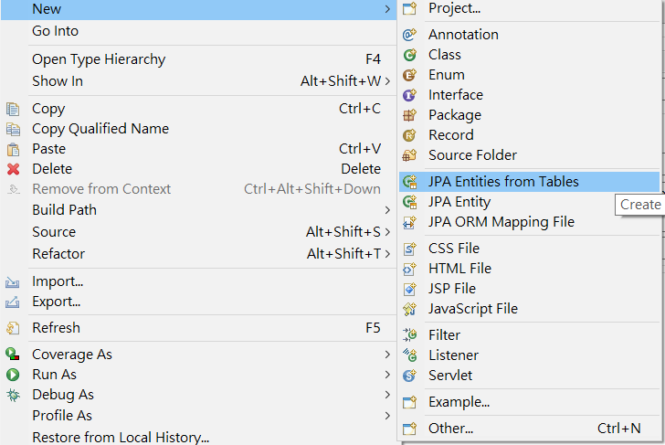
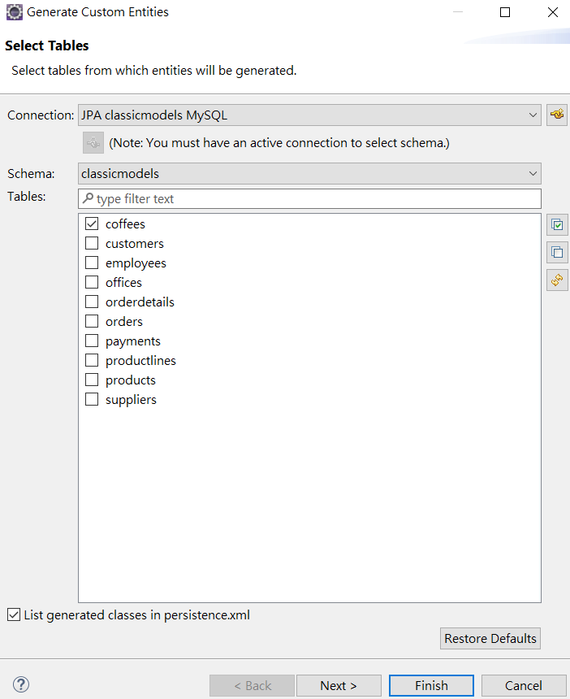

系統自行建立檔案 Coffee

import java.io.Serializable;
import jakarta.persistence.*;
import java.math.BigDecimal;

/**
* The persistent class for the coffees database table.
*
*/
@Entity
@Table(name="coffees")
@NamedQuery(name="Coffee.findAll", query="SELECT c FROM Coffee c")
public class Coffee implements Serializable {
private static final long serialVersionUID = 1L;

@Id
@Column(name="COF_NAME")
private String cofName;

private BigDecimal price;

private int sales;

@Column(name="SUP_ID")
private int supId;

private int total;

public Coffee() {
}

public String getCofName() {
return this.cofName;
}

public void setCofName(String cofName) {
this.cofName = cofName;
}

public BigDecimal getPrice() {
return this.price;
}

public void setPrice(BigDecimal price) {
this.price = price;
}

public int getSales() {
return this.sales;
}

public void setSales(int sales) {
this.sales = sales;
}

public int getSupId() {
return this.supId;
}

public void setSupId(int supId) {
this.supId = supId;
}

public int getTotal() {
return this.total;
}

public void setTotal(int total) {
this.total = total;
}

}
解決Entity Class 錯誤問題
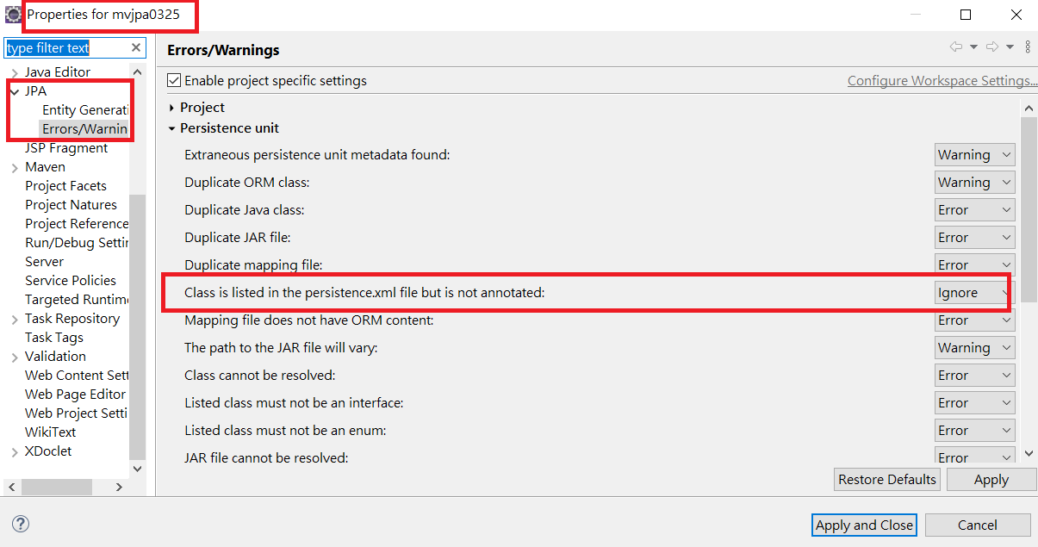
接下來建立 Controller(Servlet) 及 View 程式
protected void doGet(HttpServletRequest request, HttpServletResponse response) throws ServletException, IOException {

EntityManagerFactory factory=Persistence.createEntityManagerFactory("mvjpa0325");
EntityManager mgr=factory.createEntityManager();
TypedQuery<Coffee> tq=mgr.createNamedQuery("Coffee.findAll", Coffee.class);
List<Coffee> data=tq.getResultList();
request.setAttribute("coffees", data);
request.getRequestDispatcher("viewcoffees.jsp").forward(request, response);
}

View :
<%@ page language="java" contentType="text/html; charset=UTF-8"
pageEncoding="UTF-8"%>
<%@taglib prefix="c" uri="http://java.sun.com/jsp/jstl/core"%>
<!DOCTYPE html>
<html>
<head>
<meta charset="UTF-8">
<title>View Coffee</title>
</head>
<body>
<table border="1" width="60%">
<tr>
<th>Coffee Name</th>
<th>Supplier ID</th>
<th>Sales</th>
<th>Total</th>
<th>Price</th>

</tr>
<c:forEach var="current" items="${coffees}" >
<tr>
<td><c:out value="${current.cofName}" /></td>
<td><c:out value="${current.supId}" /></td>
<td><c:out value="${current.sales}" /></td>
<td><c:out value="${current.total}" /></td>
<td><c:out value="${current.price}" /></td>
</tr>
</c:forEach>
</table>
</body>
</html>

JPA的JPQL(Java Persistence Query Language)語法可類似SQL，但其查詢資料源是持久化物件(Entity)而非資料庫本身。

查詢全部因為Entity的名稱預設為實體的類別名稱，所以查詢的是Supplier類別而不是Supplier 表格。

EntityManager em = Persistence.createEntityManagerFactory("WebJPADemo ").createEntityManager();

String jpql = "SELECT s FROM Supplier s";

Query query = em.createQuery(jpql, Supplier.class);
List<Supplier> supplierList = query.getResultList();

查詢WHERE條件。後面的:supName是插入參數的位置，可以任意命名。所以下面的query.setParameter("arg1", supName);會將supName變數插入在 :arg1的位置

String jpql="select e from Supplier e where e.supName = :arg1";
Query query = entityManager.createQuery(jpql, Supplier.class);
query.setParameter("arg1", "Professional Kitchen");
List<Supplier> result = query.getResultList();

查詢WHERE...AND...。

EntityManager em = Persistence.createEntityManagerFactory("WebJPADemo ").createEntityManager();

String jpql = "SELECT e FROM Supplier e WHERE e.supName = :arg1 AND e.city = :arg2";

Query query = em.createQuery(jpql, Supplier.class);
query.setParameter("arg1", supName);
query.setParameter("arg2", city);
List<Supplier> supplierList = query.getResultList();
查詢LIKE條件

EntityManager em = Persistence.createEntityManagerFactory("WebJPADemo ").createEntityManager();

String jpql = "SELECT e FROM Supplier e WHERE e.supName LIKE :arg1";

Query query = em.createQuery(jpql, Supplier.class);
query.setParameter("arg1", "%" + supName + "%"); // e.g. %matt%
List<Supplier> supplierList = query.getResultList();

IS NULL

EntityManager em = Persistence.createEntityManagerFactory("WebJPADemo ").createEntityManager();

String jpql = "SELECT e FROM Supplier e WHERE e.supName IS NULL";

Query query = em.createQuery(jpql, Supplier.class);
List<Supplier> supplierList = query.getResultList();
建立Supplier DAO
package model;
import java.util.List;
import javax.persistence.EntityManager;
import javax.persistence.EntityManagerFactory;
import javax.persistence.Persistence;
import javax.persistence.PersistenceContext;

public class SupplierDAO {
@PersistenceContext
private EntityManager em;
public SupplierDAO() {
EntityManagerFactory emf =Persistence.createEntityManagerFactory("web20201103");
em = emf.createEntityManager();
}

public void addSupplier(Supplier sup) {
em.getTransaction().begin();
try {
em.persist(sup);
em.getTransaction().commit();
} catch (Exception e) {
e.printStackTrace();
em.getTransaction().rollback();
}

}

public void editSupplier(Supplier sup) {
em.getTransaction().begin();
try {

em.merge(sup);
em.getTransaction().commit();

} catch (Exception e) {
e.printStackTrace();
em.getTransaction().rollback();
}

}

public void deleteStudent(String id) {
Supplier student = em.find(Supplier.class, id);
em.getTransaction().begin();
try {
em.remove(student);
em.getTransaction().commit();
} catch (Exception e) {
e.printStackTrace();
em.getTransaction().rollback();
}
}
public Supplier getStudent(String id) {
return em.find(Supplier.class, id);
}
public List<Supplier> getAllStudents() {
return em.createNamedQuery("Supplier.findAll").getResultList();
}
}

import java.io.IOException;
import java.util.List;
import javax.servlet.ServletException;
import javax.servlet.annotation.WebServlet;
import javax.servlet.http.HttpServlet;
import javax.servlet.http.HttpServletRequest;
import javax.servlet.http.HttpServletResponse;

import model.Supplier;

/**
* Servlet implementation class SupplierDAOServlet
*/
@WebServlet("/SupplierDAOServlet")
public class SupplierDAOServlet extends HttpServlet {
private static final long serialVersionUID = 1L;

/**
* @see HttpServlet#HttpServlet()
*/
public SupplierDAOServlet() {
super();
// TODO Auto-generated constructor stub
}

/**
* @see HttpServlet#doGet(HttpServletRequest request, HttpServletResponse response)
*/
protected void doGet(HttpServletRequest request, HttpServletResponse response) throws ServletException, IOException {
// TODO Auto-generated method stub
model.SupplierDAO dao=new model.SupplierDAO();
List<Supplier> result = dao.getAllStudents();
request.setAttribute("supplier", result);
request.getRequestDispatcher("viewSupplier.jsp").forward(request, response);
}

/**
* @see HttpServlet#doPost(HttpServletRequest request, HttpServletResponse response)
*/
protected void doPost(HttpServletRequest request, HttpServletResponse response) throws ServletException, IOException {
// TODO Auto-generated method stub
doGet(request, response);
}

}

